MID-TERM

Question 01
Which protocol is used to transmit data SECURELY over the Internet?   |  |  | MC
Default mark: |  |  | 1
Shuffle the choices? |  |  | Yes
Number the choices? |  |  | A
Penalty for each incorrect try: |  |  | 33.3
# | Answers | Feedback | Grade
 | HTTP |  | 0
 | HTML |  | 0
 | HTTPS |  | 100
 | VOIP |  | 0
 | General feedback:
 | For any correct response:
 | For any incorrect response:
 | Hint 1:
 | Show the number of correct responses (Hint 1): | No
 | Clear incorrect responses (Hint 1): | No
 | Tags:
Allows the selection of a single or multiple responses from a pre-defined list. (MC/MA)

Question 02
Which is a simple and harmless text file a website puts on a user's computer that tracks a user's activity on a website?   |  |  | MC
Default mark: |  |  | 1
Shuffle the choices? |  |  | Yes
Number the choices? |  |  | A
Penalty for each incorrect try: |  |  | 33.3
# | Answers | Feedback | Grade
 | HTTPS |  | 0
 | Cookie |  | 100
 | Breadcrumb |  | 0
 | DNS |  | 0
 | General feedback:
 | For any correct response:
 | For any incorrect response:
 | Hint 1:
 | Show the number of correct responses (Hint 1): | No
 | Clear incorrect responses (Hint 1): | No
 | Tags:
Allows the selection of a single or multiple responses from a pre-defined list. (MC/MA)

Question 03
What is plagiarism? |  |  | MC
Default mark: |  |  | 1
Shuffle the choices? |  |  | Yes
Number the choices? |  |  | A
Penalty for each incorrect try: |  |  | 33.3
# | Answers | Feedback | Grade
 | Copying someone else's work or ideas and passing them off as your own. |  | 100
 | Incorrect |  | 0
 | The website is a .com domain. |  | 0
 | Modifying someone else's work without his or her permission. |  | 0
 | General feedback:
 | For any correct response:
 | For any incorrect response:
 | Hint 1:
 | Show the number of correct responses (Hint 1): | No
 | Clear incorrect responses (Hint 1): | No
 | Tags:
Allows the selection of a single or multiple responses from a pre-defined list. (MC/MA)

Question 04
Which one of these companies allows you to create an email account through their services? |  |  | MC
Default mark: |  |  | 1
Shuffle the choices? |  |  | Yes
Number the choices? |  |  | A
Penalty for each incorrect try: |  |  | 33.3
# | Answers | Feedback | Grade
 |  |  | 0
 |  |  | 100
 |  |  | 0
 |  |  | 0
 | General feedback:
 | For any correct response:
 | For any incorrect response:
 | Hint 1:
 | Show the number of correct responses (Hint 1): | No
 | Clear incorrect responses (Hint 1): | No
 | Tags:
Allows the selection of a single or multiple responses from a pre-defined list. (MC/MA)

Question 05
What are two benefits of using web email instead of a desktop email application? |  |  | MC
Default mark: |  |  | 1
Shuffle the choices? |  |  | Yes
Number the choices? |  |  | A
Penalty for each incorrect try: |  |  | 33.3
# | Answers | Feedback | Grade
 | Web email doesn't require an Internet connection. |  | 0
 | Web email is accessible from any device with a browser. |  | 50
 | Web email does not require the installation of an application. |  | 50
 | Web email offers more management capabilities than a desktop email application. |  | 0
 | Web email is confined to a physical location. |  | 0
 | General feedback:
 | For any correct response:
 | For any incorrect response:
 | Hint 1:
 | Show the number of correct responses (Hint 1): | No
 | Clear incorrect responses (Hint 1): | No
 | Tags:
Allows the selection of a single or multiple responses from a pre-defined list. (MC/MA)

Question 06
Which THREE Linkedin characteristics can benefit someone professionally?   |  |  | MC
Default mark: |  |  | 1
Shuffle the choices? |  |  | Yes
Number the choices? |  |  | A
Penalty for each incorrect try: |  |  | 33.3
# | Answers | Feedback | Grade
 | Linkedin does not send out notifications. |  | 0
 | Linkedin can suggest jobs that match your profile. |  | 33.3
 | Linkedin can report who has viewed your profile to you. |  | 33.3
 | Linkedin can display your credentials as your public profile. |  | 33.3
 | Linked in doesn't have any advertising. |  | 0
 | General feedback:
 | For any correct response:
 | For any incorrect response:
 | Hint 1:
 | Show the number of correct responses (Hint 1): | No
 | Clear incorrect responses (Hint 1): | No
 | Tags:
Allows the selection of a single or multiple responses from a pre-defined list. (MC/MA)

Question 07
Online video conferencing and online audio conferencing are synchronous. What does this mean? (The opposite of synchronous is asynchronous.)  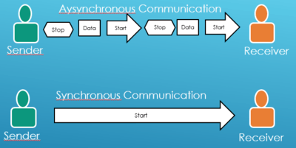 |  |  | MC
Default mark: |  |  | 1
Shuffle the choices? |  |  | Yes
Number the choices? |  |  | A
Penalty for each incorrect try: |  |  | 33.3
# | Answers | Feedback | Grade
 | Communications take place in real time. |  | 100
 | Participants have identical browsers. |  | 0
 | All participant posts and files are updated simultaneously (at the same time). |  | 0
 | People in different time zones can participate when convenient for them. |  | 0
 | General feedback:
 | For any correct response:
 | For any incorrect response:
 | Hint 1:
 | Show the number of correct responses (Hint 1): | No
 | Clear incorrect responses (Hint 1): | No
 | Tags:
Allows the selection of a single or multiple responses from a pre-defined list. (MC/MA)

Question 08
Which of these takes you to the Settings menu in Chrome?  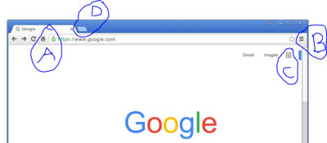 |  |  | MC
Default mark: |  |  | 1
Shuffle the choices? |  |  | Yes
Number the choices? |  |  | A
Penalty for each incorrect try: |  |  | 33.3
# | Answers | Feedback | Grade
 | A |  | 0
 | B |  | 100
 | C |  | 0
 | D |  | 0
 | General feedback:
 | For any correct response:
 | For any incorrect response:
 | Hint 1:
 | Show the number of correct responses (Hint 1): | No
 | Clear incorrect responses (Hint 1): | No
 | Tags:
Allows the selection of a single or multiple responses from a pre-defined list. (MC/MA)

Question 09
Which graph best represents $y=10 {(0.85)}^{x}$ ?  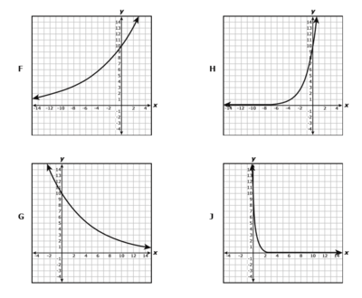 |  |  | MC
Default mark: |  |  | 1
Shuffle the choices? |  |  | Yes
Number the choices? |  |  | A
Penalty for each incorrect try: |  |  | 33.3
# | Answers | Feedback | Grade
 | F |  | 0
 | G |  | 100
 | H |  | 0
 | J |  | 0
 | General feedback:
 | For any correct response:
 | For any incorrect response:
 | Hint 1:
 | Show the number of correct responses (Hint 1): | No
 | Clear incorrect responses (Hint 1): | No
 | Tags:
Allows the selection of a single or multiple responses from a pre-defined list. (MC/MA)

Question 10
The graph of a quadratic function is shown on the grid. Which function is best represented by the graph?  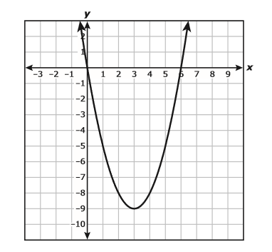 |  |  | MC
Default mark: |  |  | 1
Shuffle the choices? |  |  | Yes
Number the choices? |  |  | A
Penalty for each incorrect try: |  |  | 33.3
# | Answers | Feedback | Grade
 | 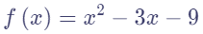 |  | 0
 | 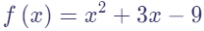 |  | 0
 | 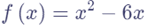 |  | 100
 | 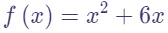 |  | 0
 | General feedback:
 | For any correct response:
 | For any incorrect response:
 | Hint 1:
 | Show the number of correct responses (Hint 1): | No
 | Clear incorrect responses (Hint 1): | No
 | Tags:
Allows the selection of a single or multiple responses from a pre-defined list. (MC/MA)

